## Recap

Modern communication technologies are affecting human civilization by many ways, it is creating job, changing lifestyle and human communication behaviour, creating new business opportunities, eliminating old technology based business and products. According natural law customer's demand is increasing, 80% data traffic increased between 2012-2013 mostly because of new Smartphones, tablets and mobile routers. Use of mobile for internet communication purpose is now far ahead than normal voice traffic and the trend is increasing exponentially. Estimated mobile data growth between 2013-2019 among the all the contents is about 10 times. Even though a router user 20 times more data then mobile but large number of mobile subscription increasing network load. If we look at inside of mobile data what is really transferring node to node we found video is the biggest contributor with 30% -50% data, social networking and web browsing in the second and third position.

Wideband Code Division Multiple Access (WCDMA) technology is currently leading mobile equipment industry with more than $ 20 billion investment. In the year 2013, there was about 6.6 billion cellular connection worldwide GSM technology remain most popular with 67% market share. Users expecting high speed internet therefore 92% of all cellular is providing 3G service. As there is a huge population in Asia therefore half of the mobile subscription of world is there, Africa, Latin America and Western Europe keep about 10% each. LTE technology is emerging which effecting the market share of GSM, CDMA, and even HSPA. Within next 5 year estimated market share would be around 20%, while HSPA to be around 65%. So far LTE and HSPA+ are on top for peak DL/UL 150Mbps and 42Mbps. HSPA is covering developed world while LTE is more popular in developing countries. Prediction about GSM is still safe as long as human need to make reliably voice calls.

3G and 4G are the most common user expected mobile broadband standards. In developed world 3G is already become old fashion. In 4G a client should get data rate of 100 Mbit/s while moving in a high speed and in at fix position 1 Gbit/s. To attract customer, some service provider are advertising 4G service even though data speed is far behind than standard therefore Peruvian telecoms regulator Osiptel has forbidden providers of mobile and fixed wireless services from using the terms "4G". Huge research on 5G is running many places to make broadband internet connectivity widely available. EU spends 50€ million in 2013, while china also deployed first phase of research; Samsung, Ericsson, and other producers are also in the race. To spread out technology different party playing different roll, e.g. mobile terminal vendor, chipset producer, network provider, service operator; combined effort of everyone make it possible.

## Problem

By studying the slides I have learnt mostly technological evolution but how mobile internet is effecting our social life was not fully described. There was nice demonstration of current information, data about Finland was expected. Negative aspects of high speed internet could make us aware. Feedback from end user could make the picture more reliable from real life point of view.

## Perception

Good connectivity is always appreciated, I came Finland 2009 while there was not high speed internet in my home country (Bangladesh). I could not see my family member through video call, even quality of audio call was not in satisfy level. Now that problem has been solved by mobile operators there. New services ( mobile banking, News update etc.) are coming in market as the blessing of 3G. Many call centre has been set up there to earn foreign revenue.

## Criticism

I found at some point mobile technology is bit control less, it pushing us always to spend money on it. Teenager specially in developing country are becoming addicted and manner less. Crime in China for iPhone or Android is a regular incident. Big multinational companies opening factories in poor countries and polluting environment. Base station, tower or other infrastructure occupying crops fields in India, Vietnam, Bangladesh.

## Deepening

Currently LTE 4G is the most speedy mobile internet network. Some key point about LTE 4G

* Australia 24.5Mbps - Fastest country with LTE.
* Claro Brazil 27.8 Mbps - Fastest Network with LTE.
* Japan 66% LTE improvement - Most Improved country for LTE speed.
* Tele2Sweden 93% coverage - Network with best coverage.
* South Korea 91% coverage - Country with best coverage.

As of February 2014 there are 76 countries with LTE currently active. Following graph shows top download speed nations of LTE 4G world wide

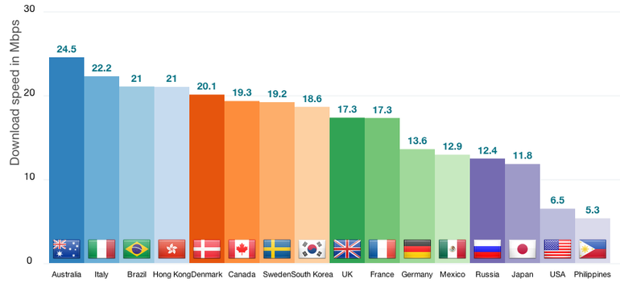

IPv6 support is another major feature of 4G. 3G which is based on two parallel infrastructures consisting of circuit switched and packet switched network nodes but 4G will be based on packet switching only. The process of IPv4 address exhaustion was expected to be in its final stages at the initial period of 4G deployment. Therefore, in the context of 4G, IPv6 is essential to support a large number of wireless-enabled devices.

Khandker, Syed Ibrahim

WISE